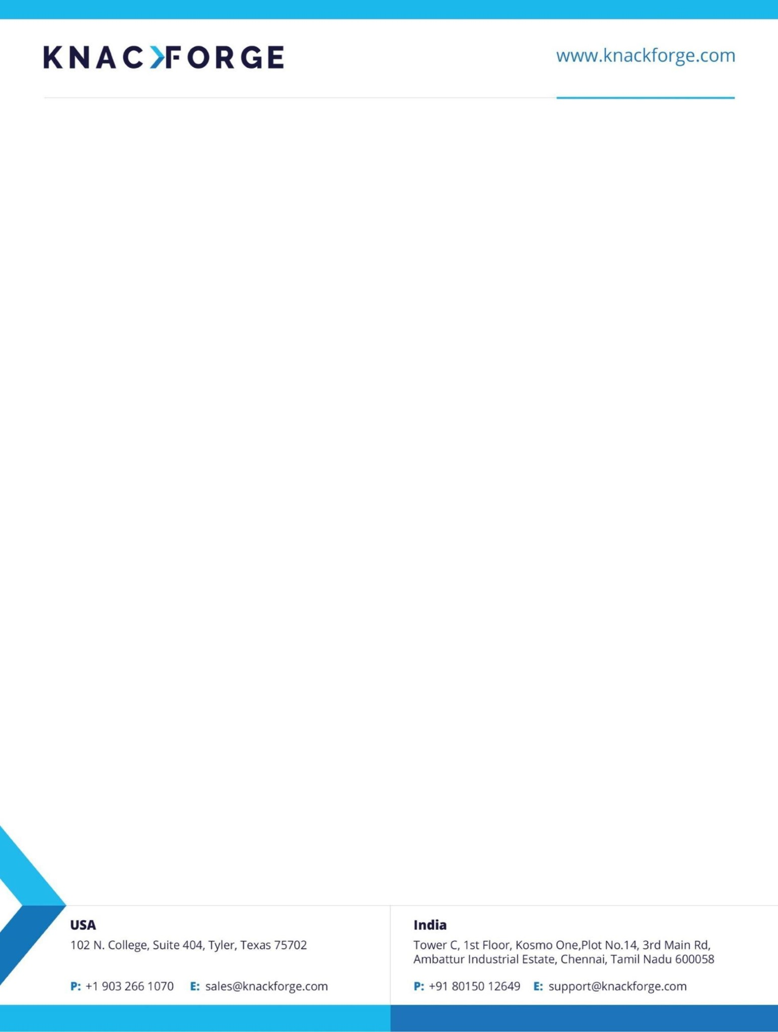

HR/KF/IL/0

9

/24

09

August

2024

**ATTENDANCE CERTIFICATE**

The Student Ms. **Shalini K** (Reg.No: 513321104040), studying B.E programme at University College of Engineering Arni in semester VII at Department of Computer Science and Engineering has attended Internship from **July 10,2024**, to **August 09,2024** in **Front end Development.** It is certified that she has completed the Internship in our organization.

.

**For KnackForge Soft Solutions Pvt Ltd.,**

**Devasena S.**

**Senior HR Manager**

